CRM APPLICATION FOR JEWEL MANAGEMENT

SK

COLLEGE NAME : SREE NARAYANA GURU COLLEGE

COIMBATORE

COLLEGE CODE : BRU36

TEAM ID : NM2025TMID26495

TEAM MEMBERS : 4

TEAM LEADER NAME : MOHANAPRIYA M

E-MAIL :  mohanamaha2006@Gmail.com

TEAM MEMBER 1 : FATHIMA A

E-MAIL :  Fpaathuzz63@Gmail.com

TEAM MEMBER : MADHUMITHA A

E-MAIL : :  Arumugammadhu9797@Gmail.com

\

TEAM MEMBER : SAKTHIVEL K

E-MAIL :  shakthiofficial9@Gmail.com

# 1.INTRODUCTION

1.1 PROJECT OVERVIEW

* Jewellery management in a CRM (Customer Relationship Management) system is specialized software designed for jewelry businesses to centralize customer data, manage interactions, and optimize sales and inventory.
* It helps jewelers understand customer preferences and purchase history to provide personalized service, automate follow-ups, and track sales and orders efficiently. By analyzing data, a jewelry CRM can also improve inventory management, suggest targeted marketing campaigns, and ultimately foster customer loyalty and drive business growth.

SK

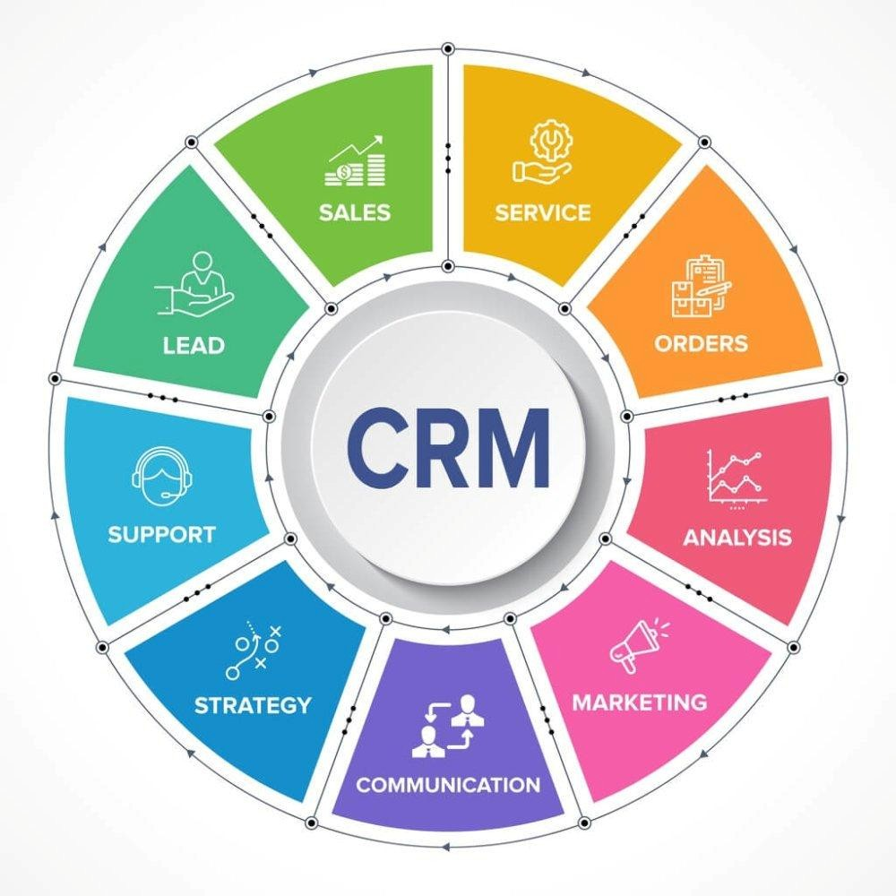

1.2 PURPOSE

* The primary purpose of jewellery management in a CRM is to enhance customer satisfaction and loyalty by providing personalized service, tracking purchase history and preferences, and facilitating targeted marketing and engagement.

# DEVELOPMENT PHASE

CREATING DEVELOPER ACCOUNT :

BY USING THIS URL : https://www.salesforce.com/form/developer-signup/

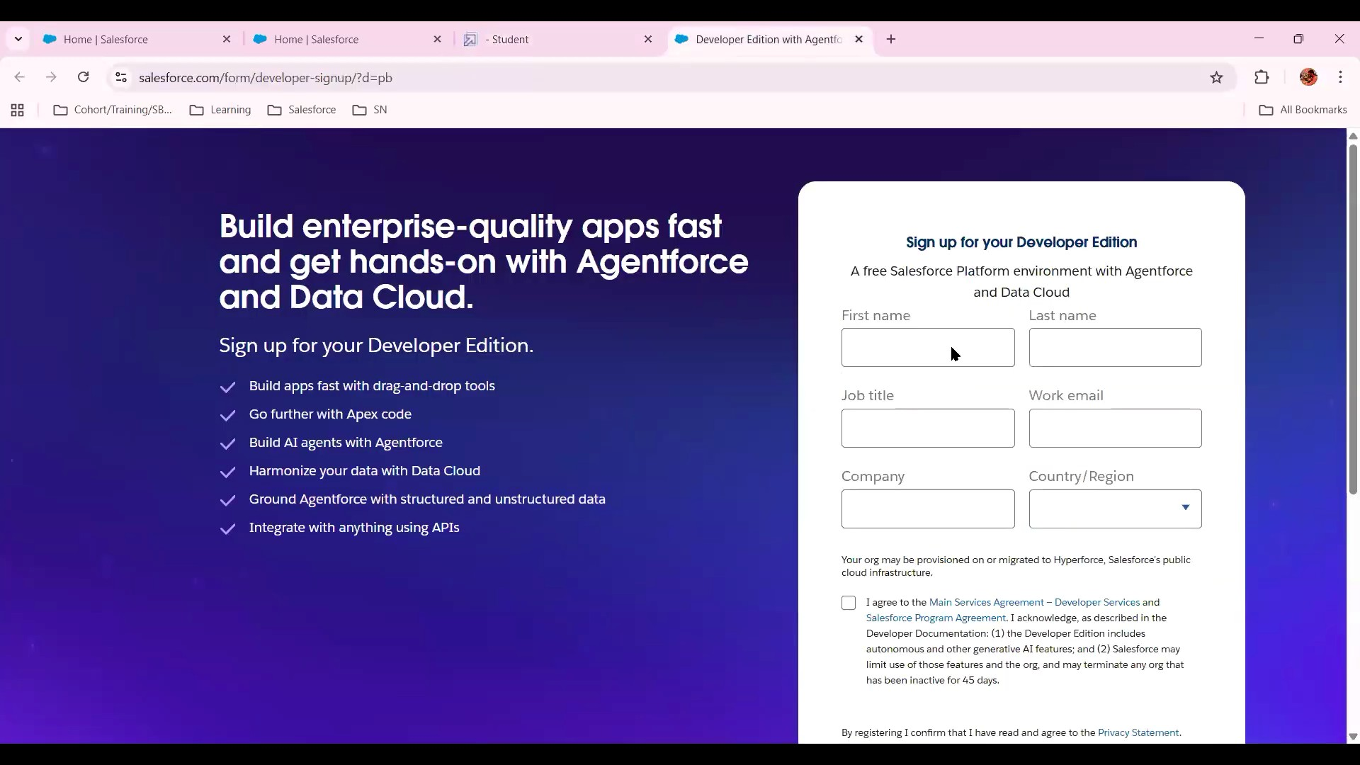

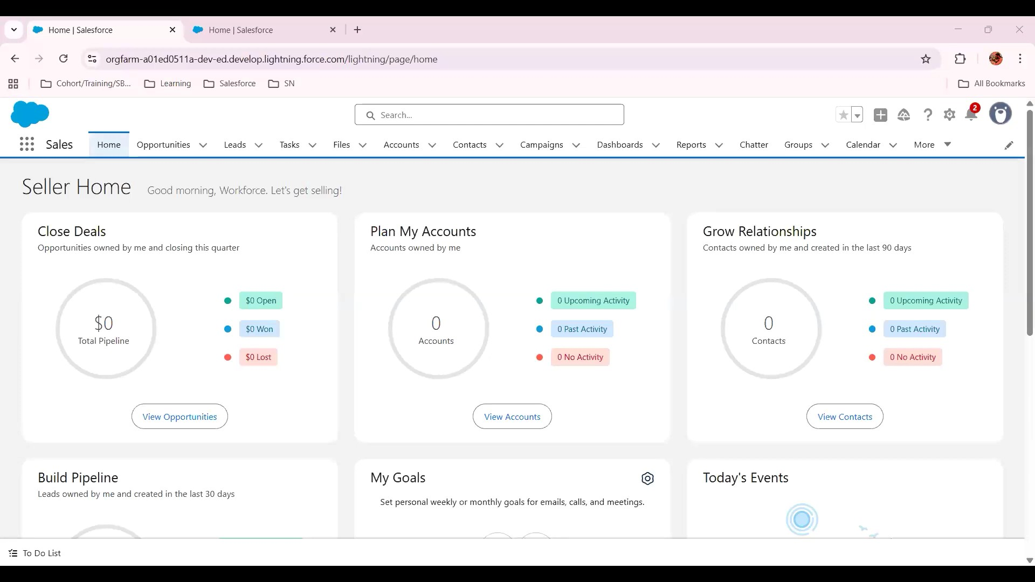

Created objects: Property, Tenant, Lease, Payment

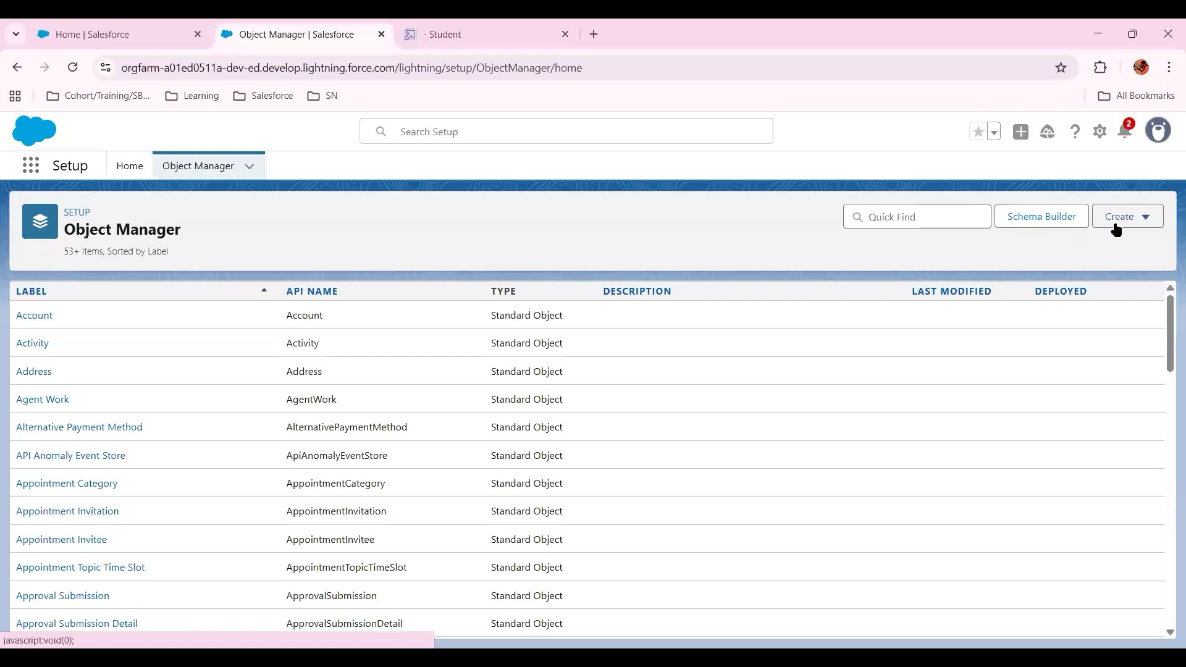

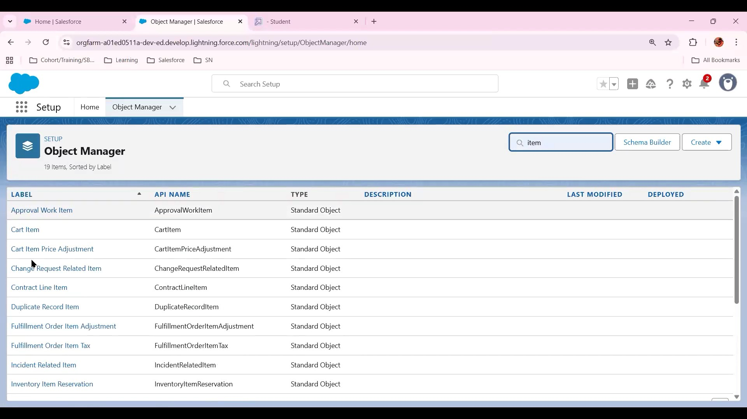

* Configured fields and relationships

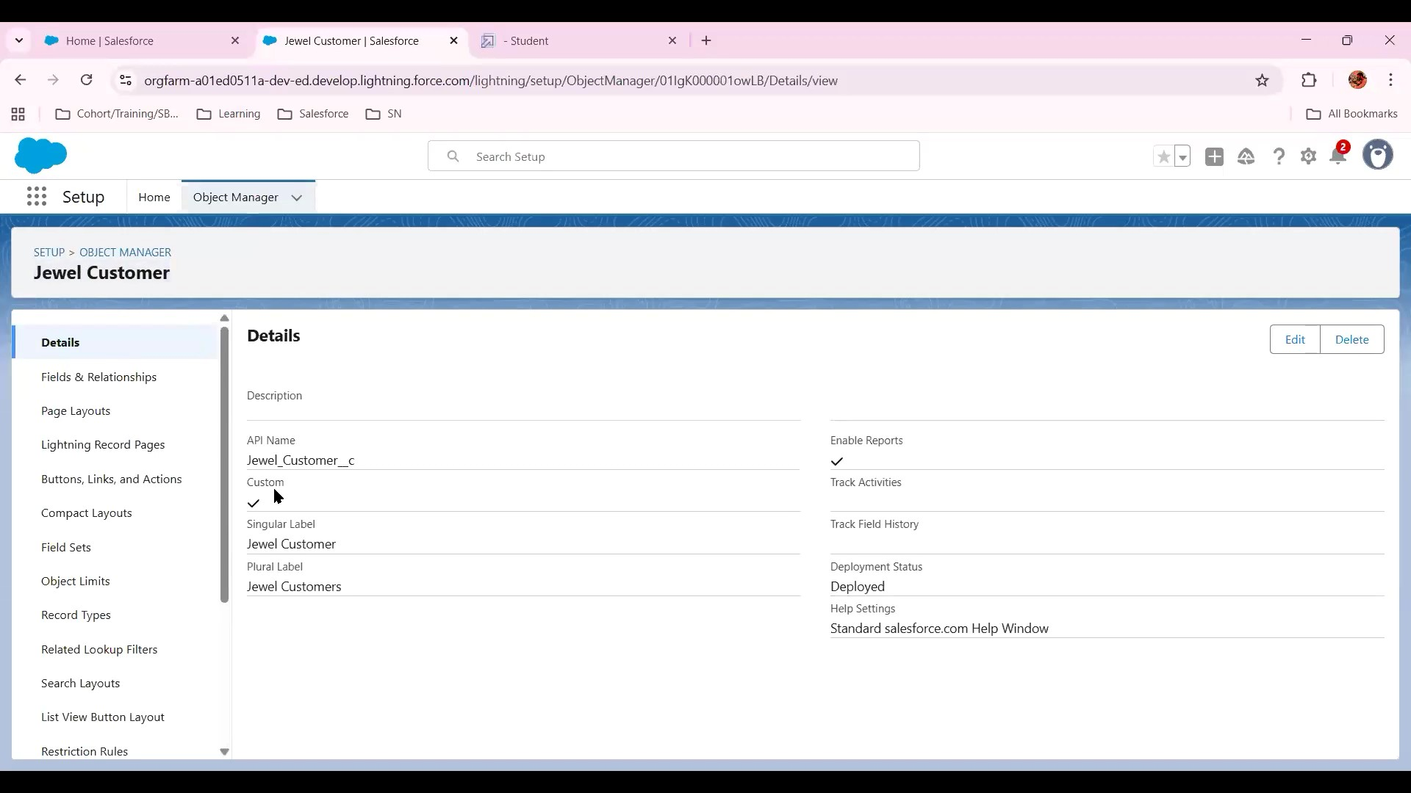

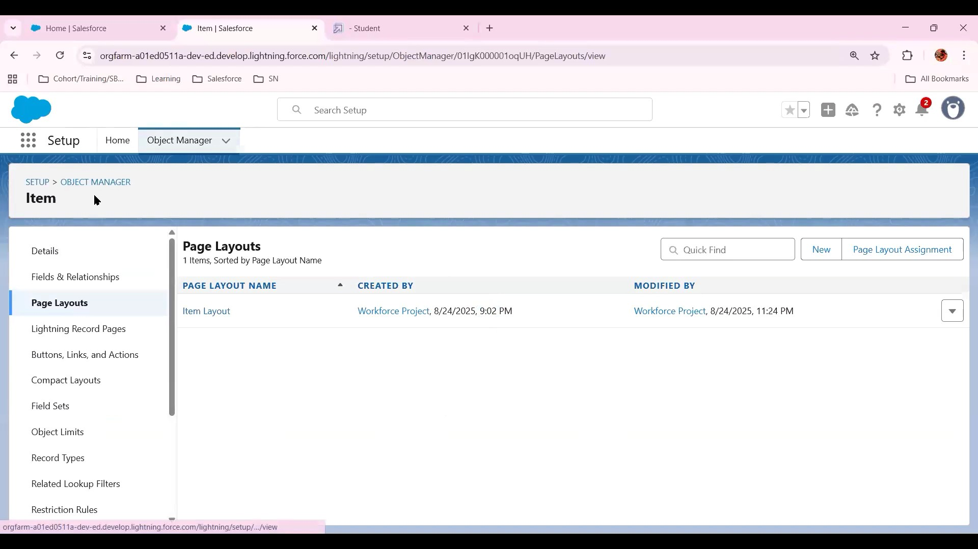

Create New Custom Object

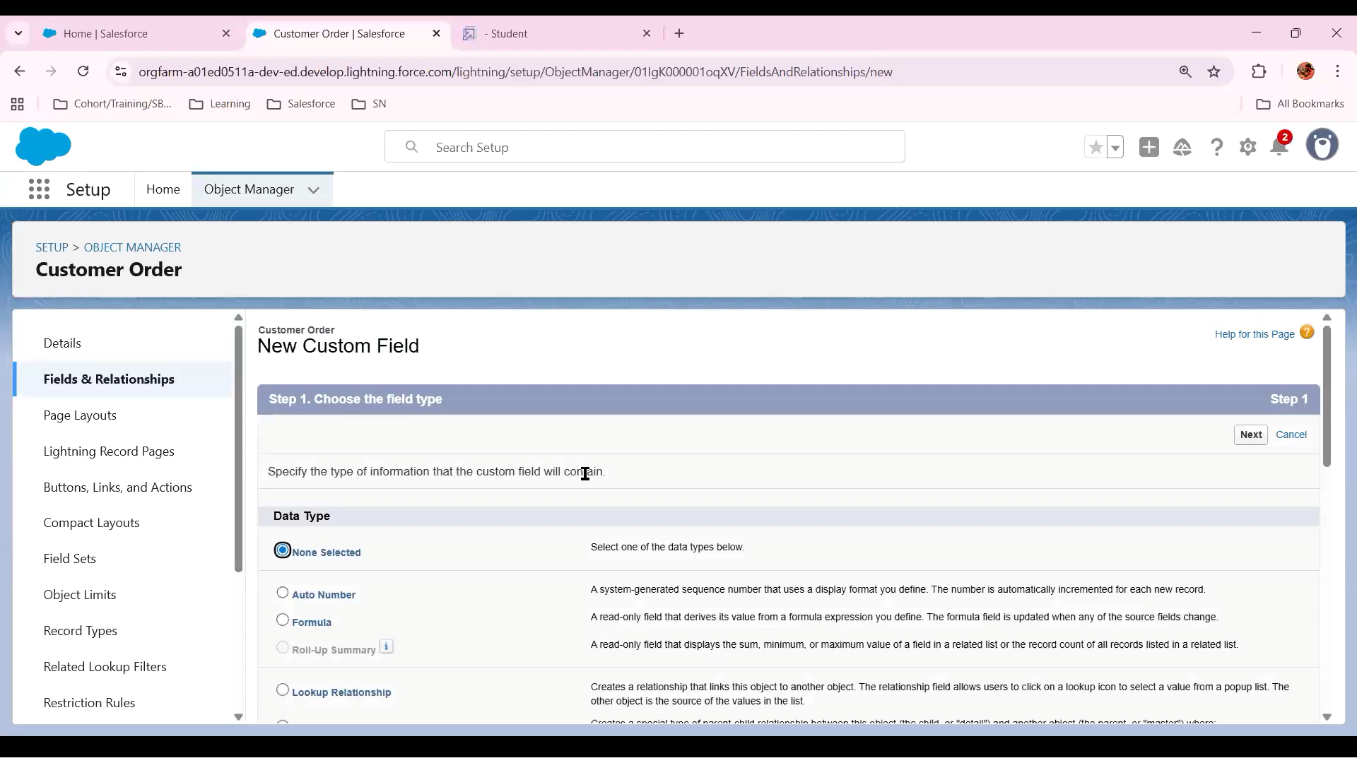

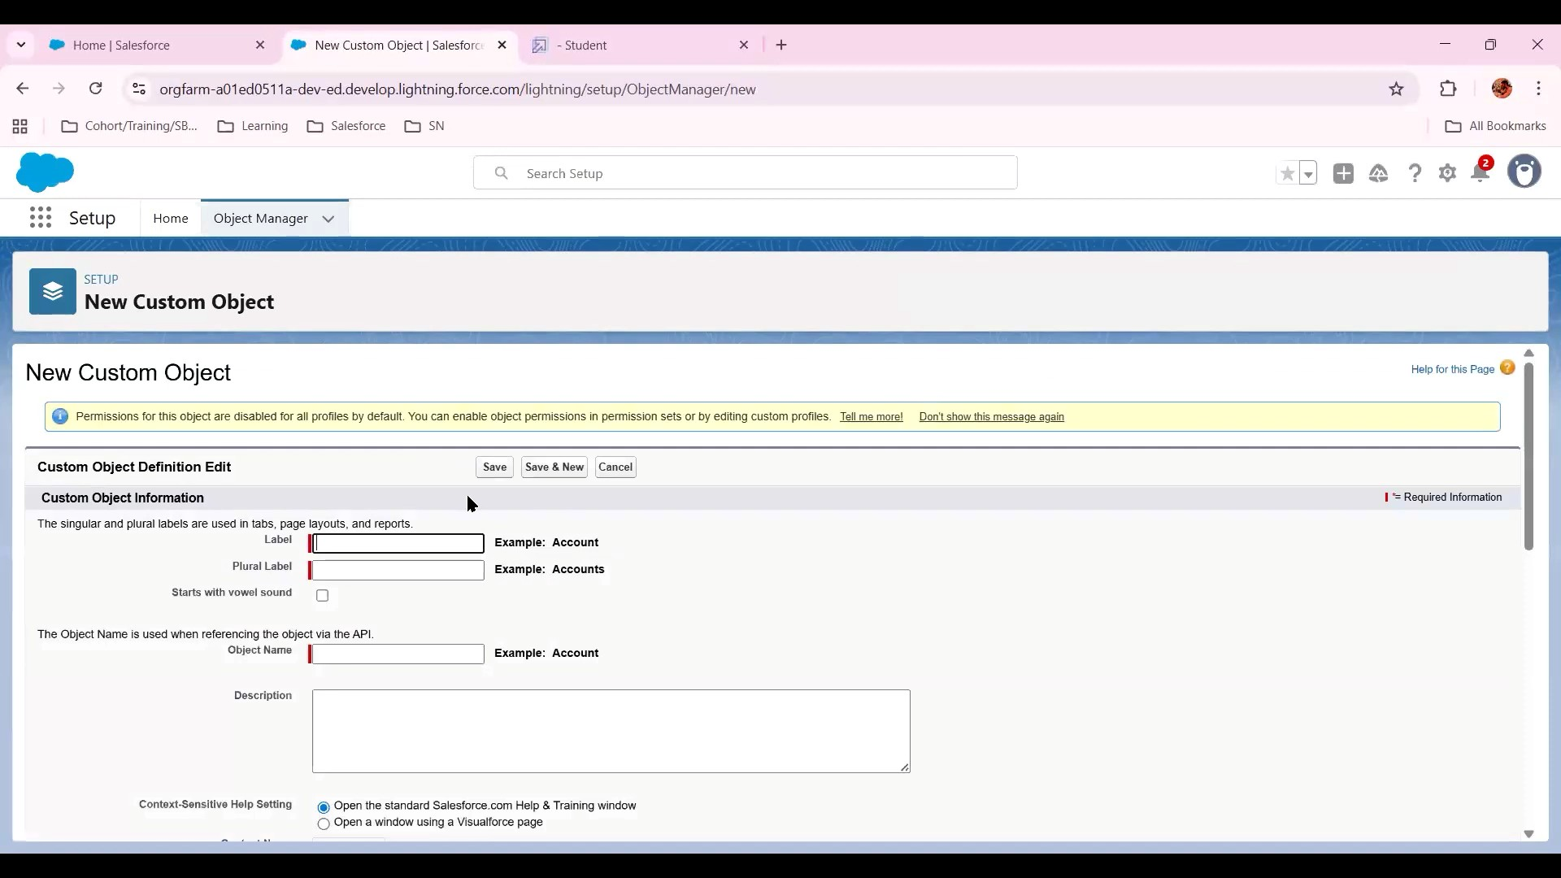

* Create New User and Roles

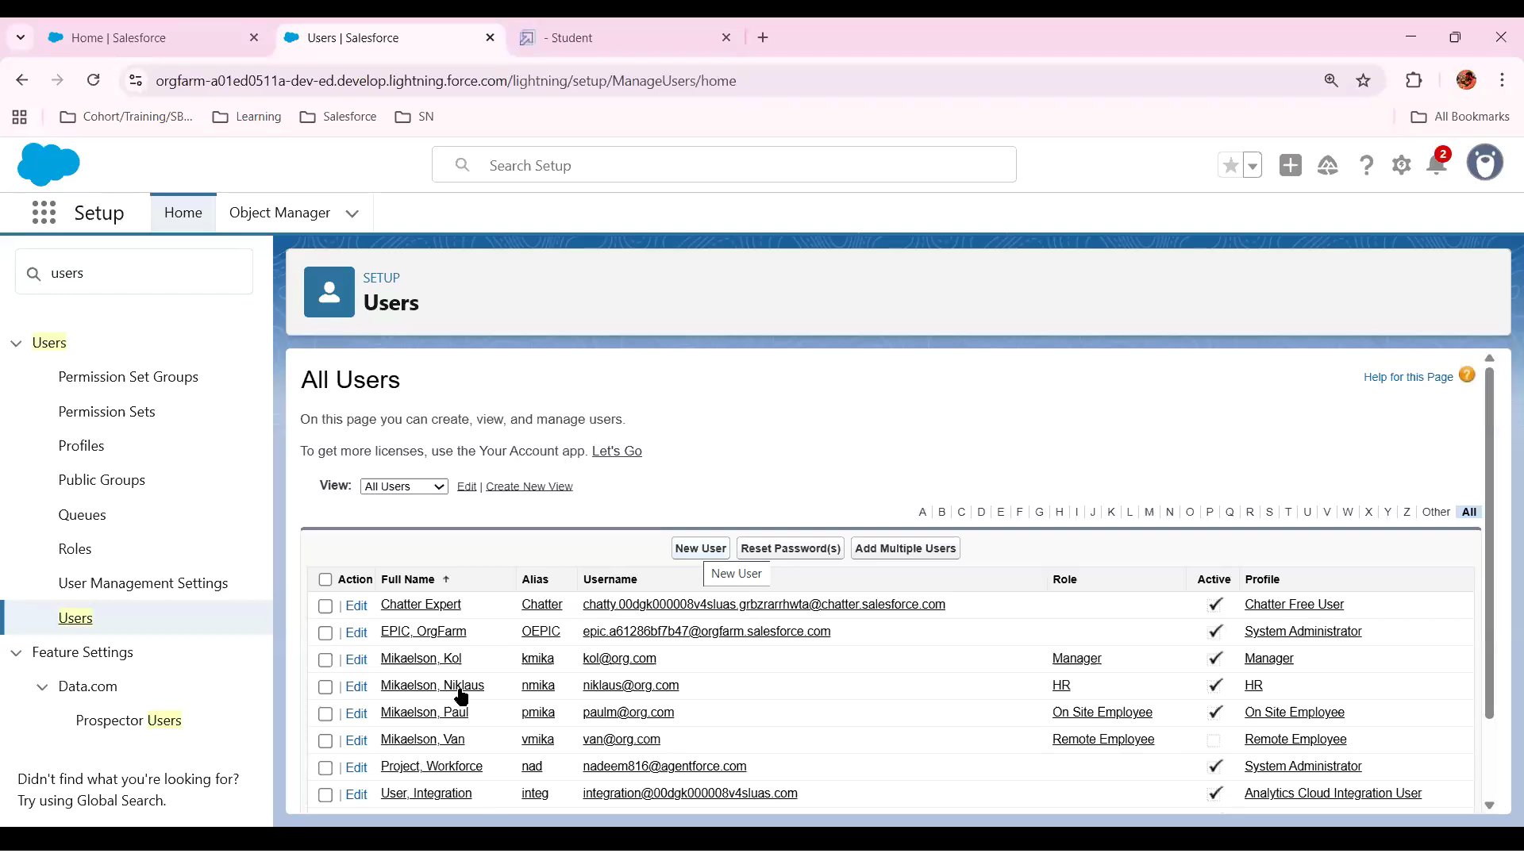

SAKTHI

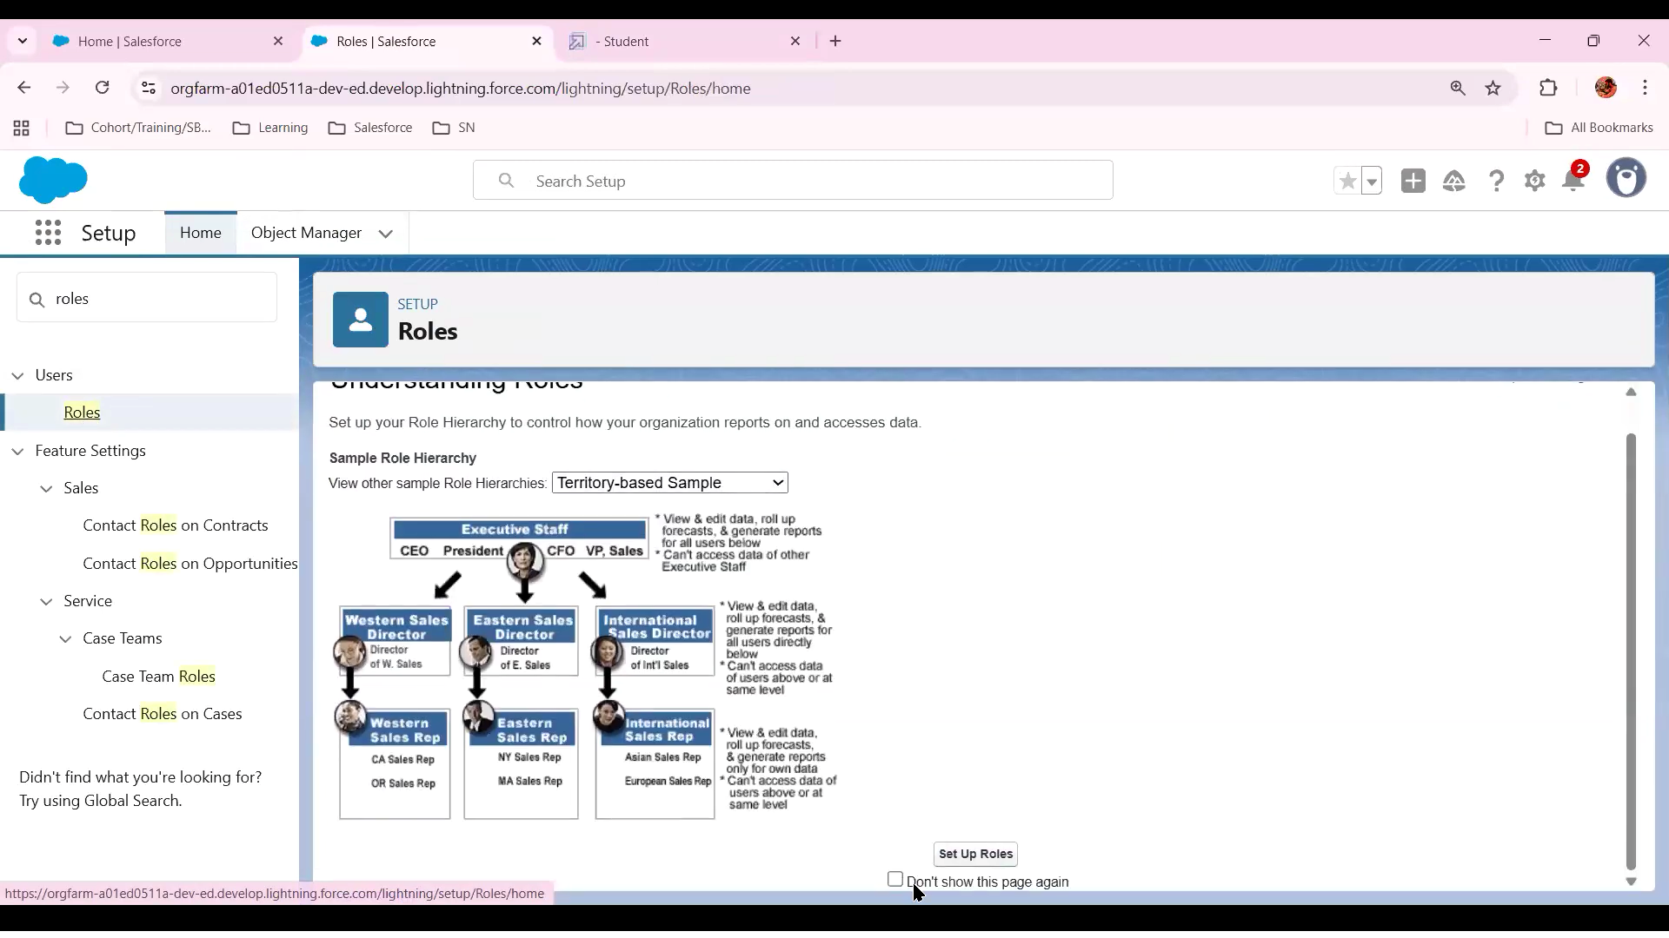

Create New Lighting App

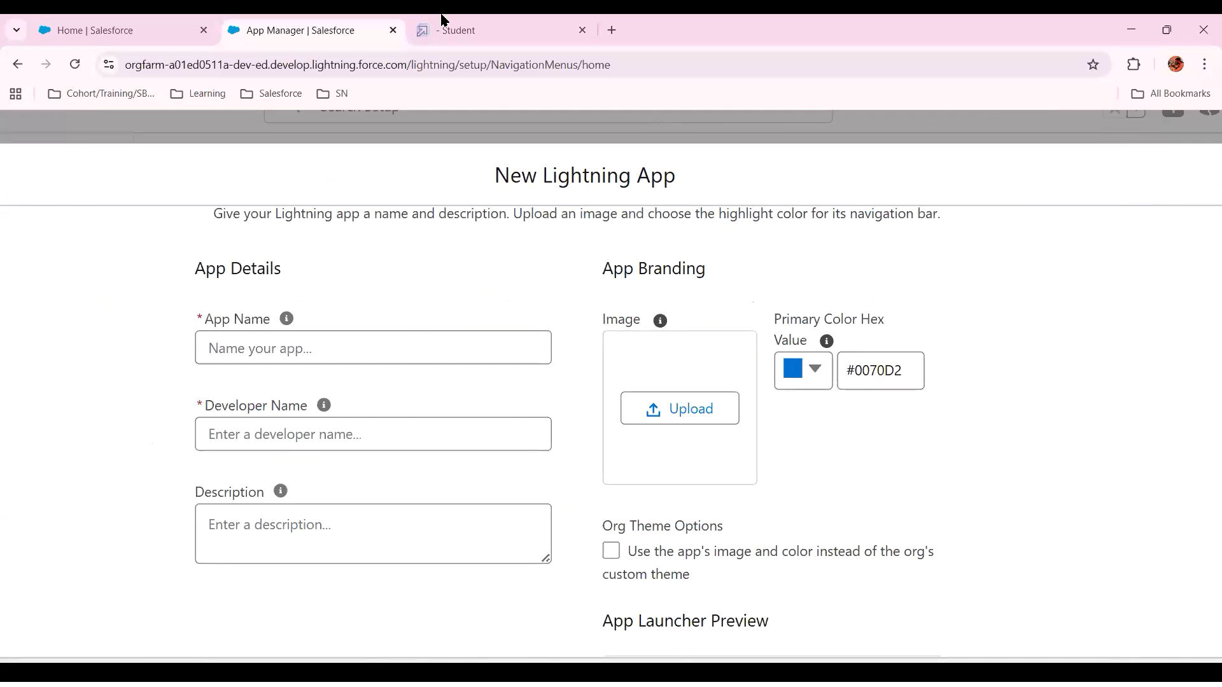

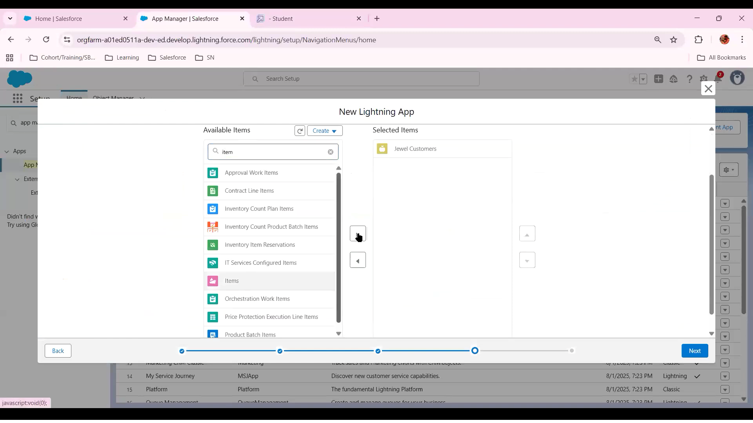

* Create An Apex Class

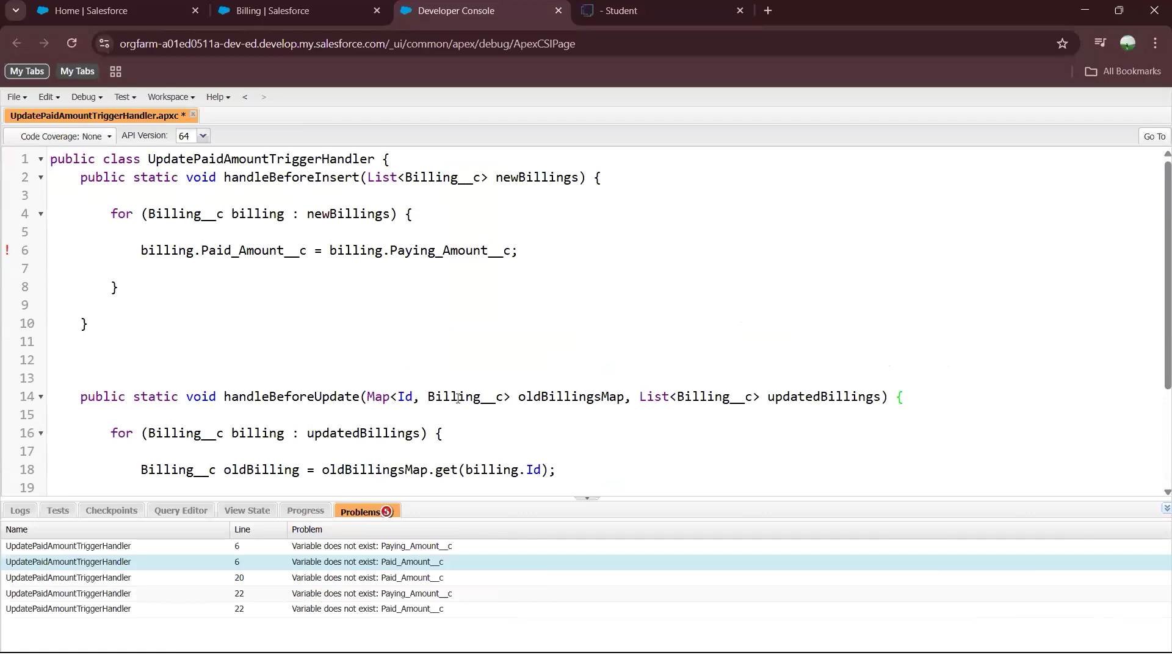

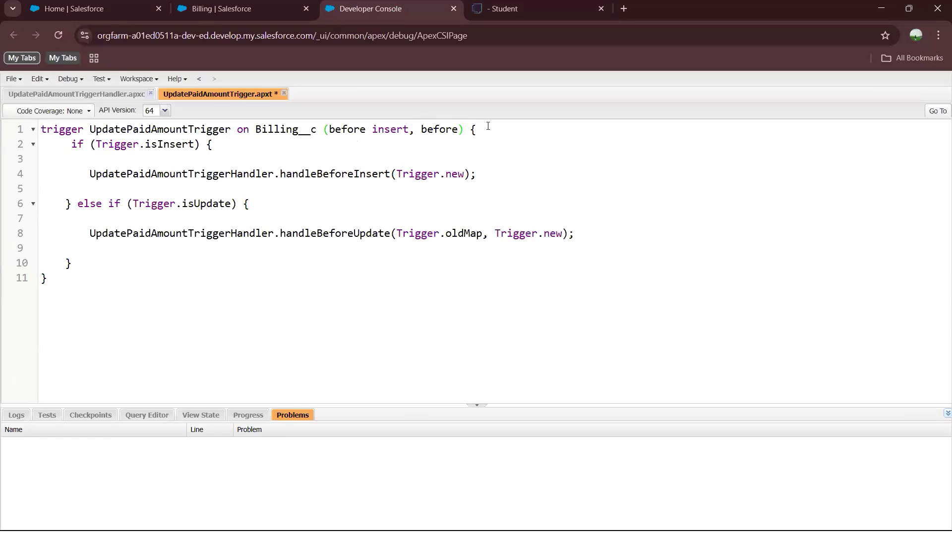

* Go to Home and Search For Jewellery Inventory System

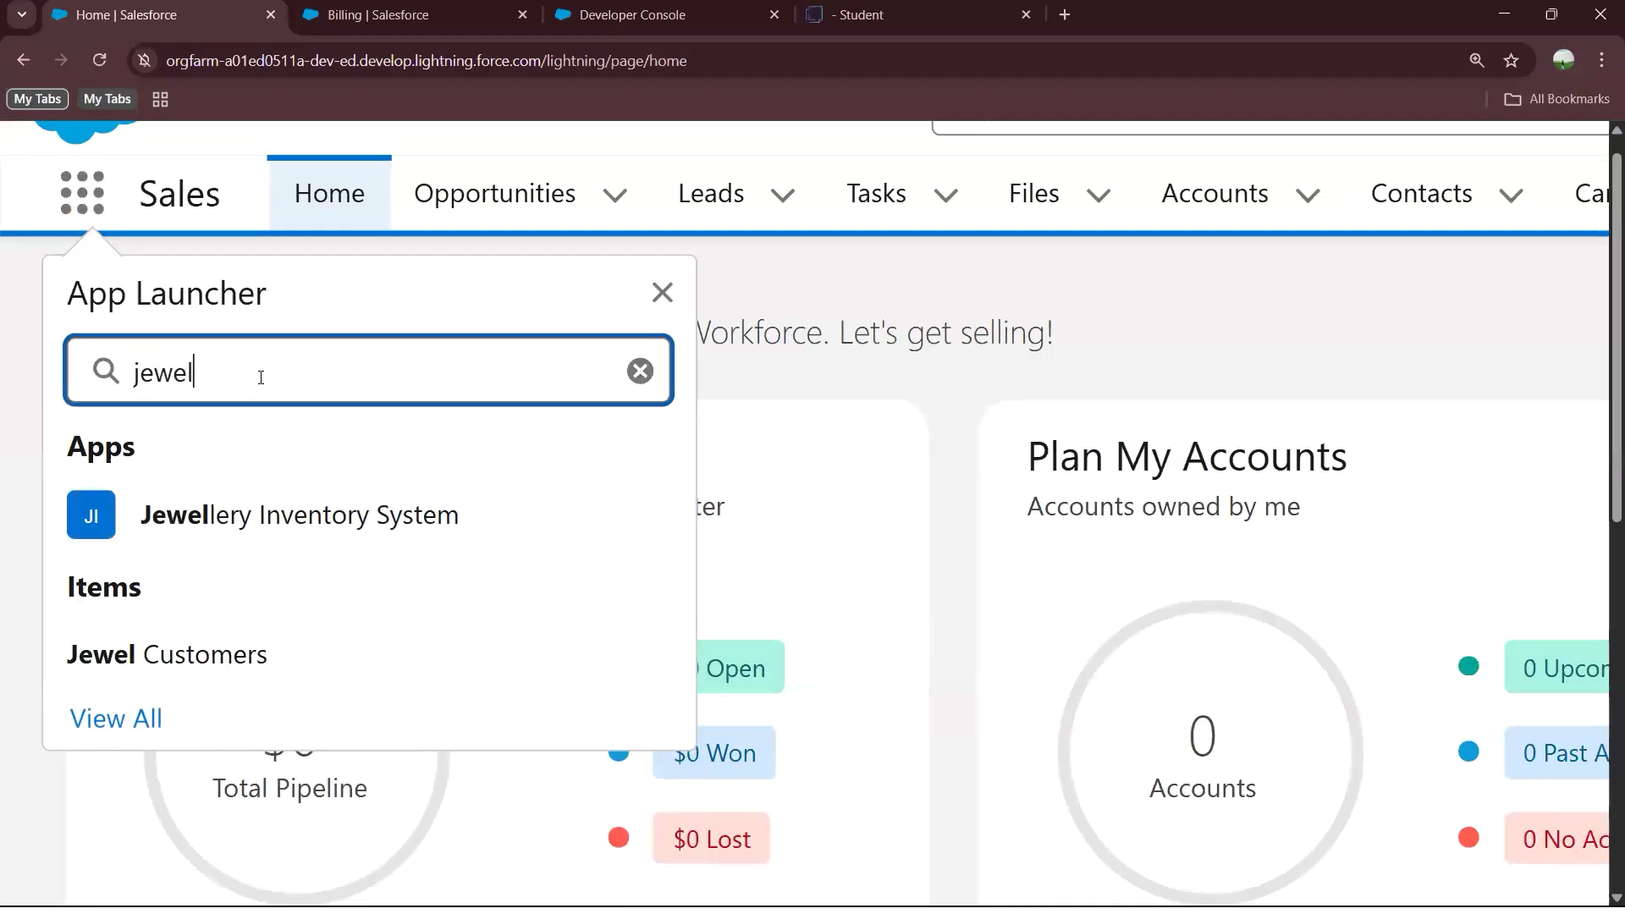

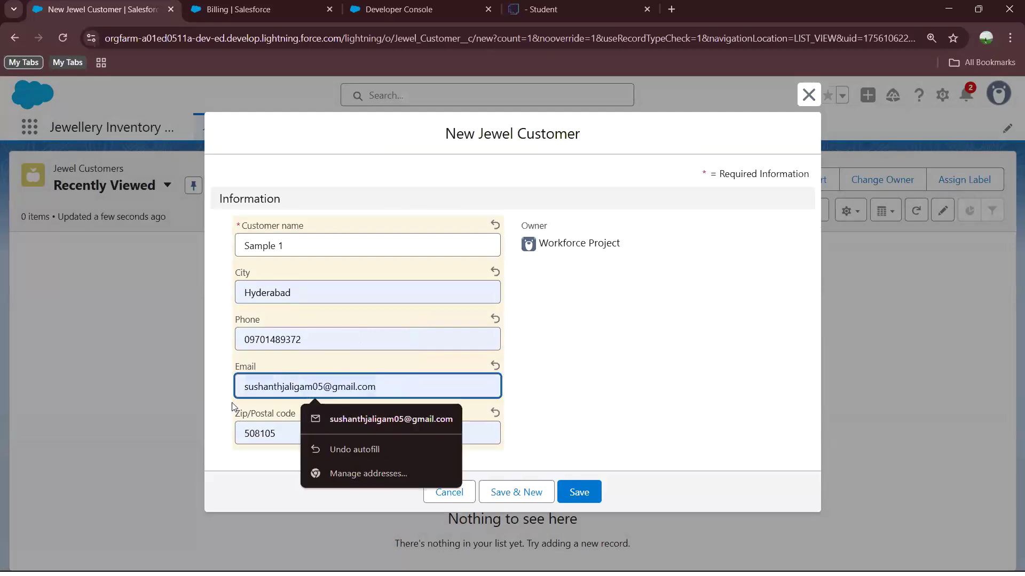

SK

* Create New Customer and Give Price

SAKTHIVEL



SK

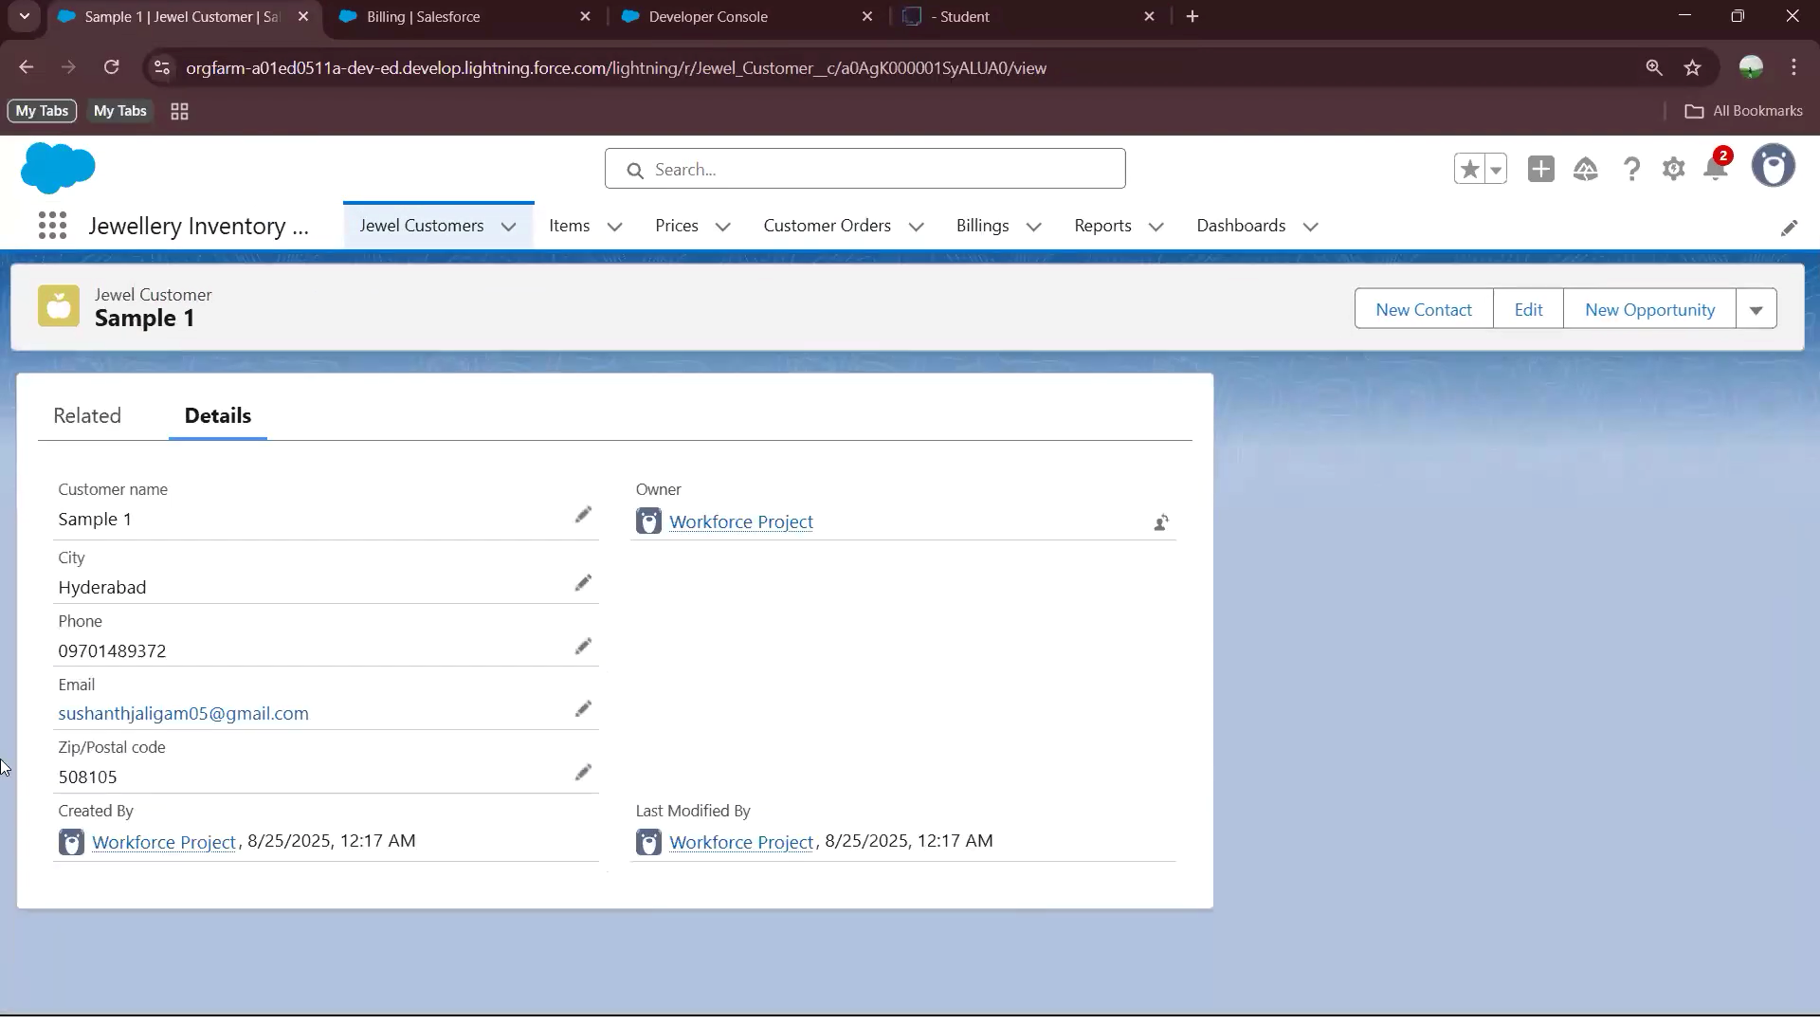

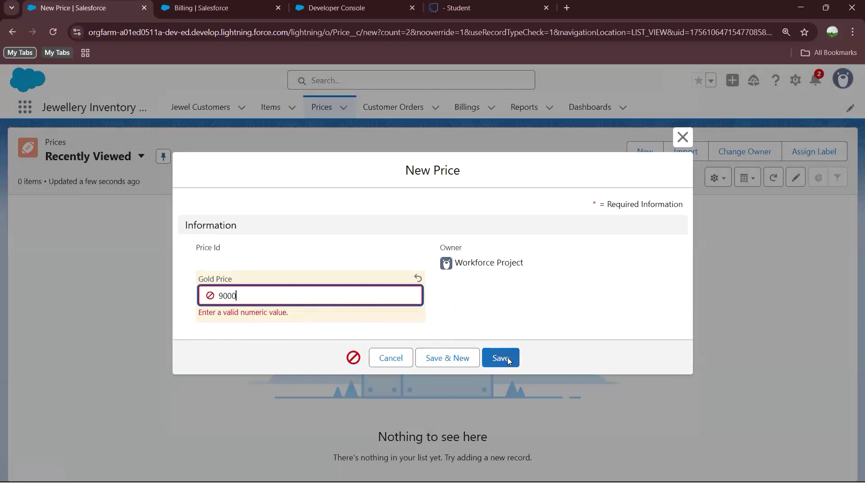

* Check For Price Report

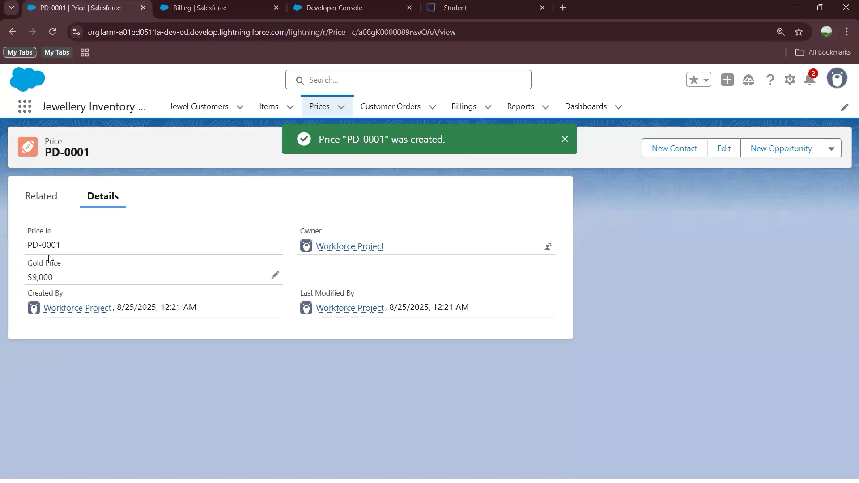

SAKTHI

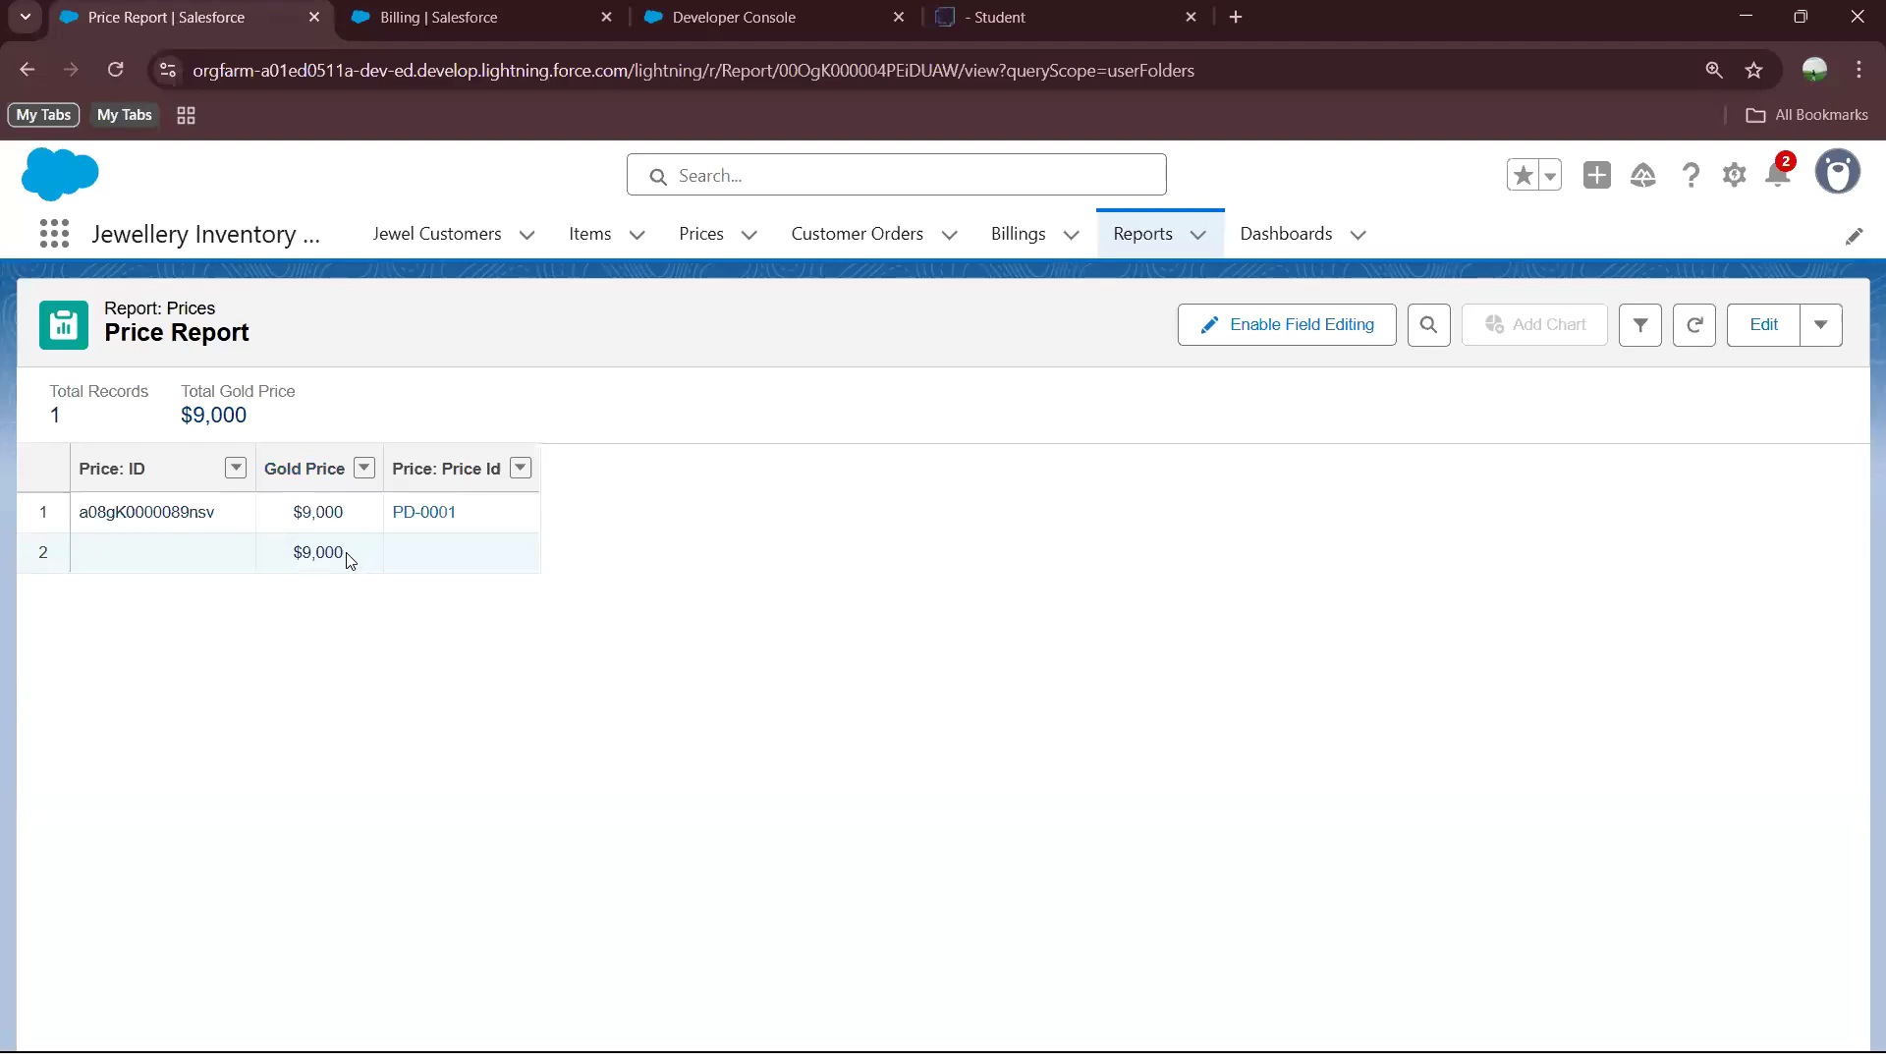

SAKTHIVE

* Create New Automation and Start

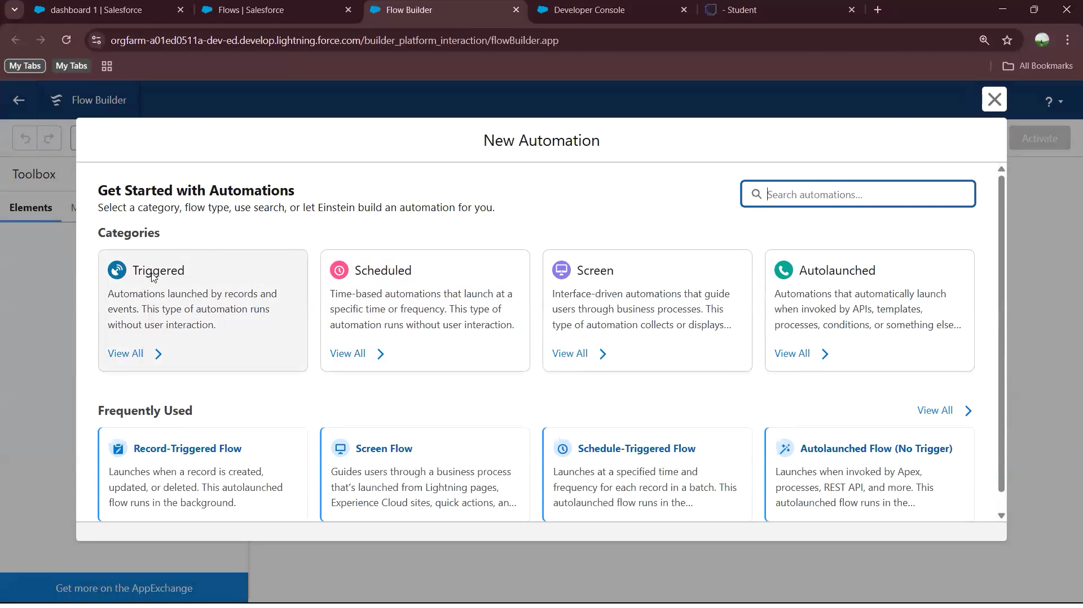

SK

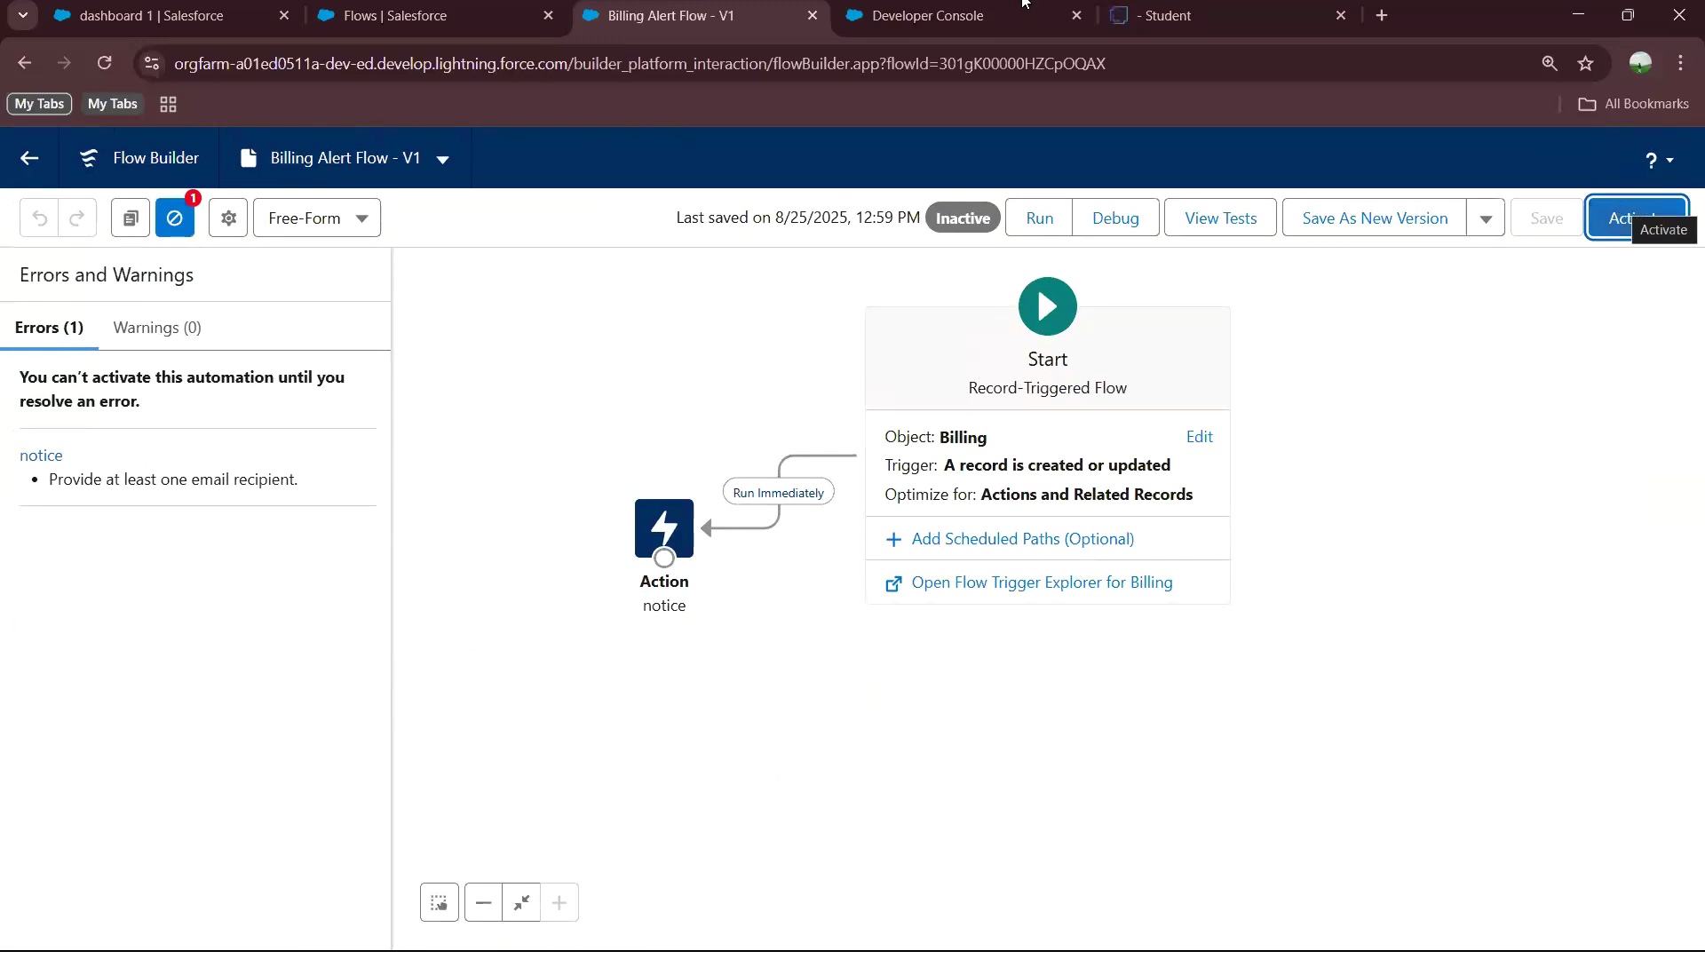

ADVANTAGES :

1. DOMAIN-SPECIFIC SOLUTION :

* + Focused on jewelry business needs like inventory tracking (gold, diamonds, stones), customized billing, and customer preferences.

* + Easier to target a niche market compared to generic CRMs.

1. SCALABILITY & FLEXIBILITY :

* + Developers can design the system to handle both small jewelry shops and larger chains.

* + Can integrate features like loyalty programs, gemstone certifications, and repair tracking.

1. INTEGRATION OPPORTUNITIES :

* + Can connect with POS systems, e-commerce websites, and accounting tools.

* + Increases product value and gives developers scope to expand modules.

1. DATA-DRIVEN INSIGHTS :

* + Offers jewelers customer insights (purchase history, trends).

* + Developers can implement analytics dashboards, improving usability and business decision-making.

1. USER-FRIENDLY UI FOCUS :

* + Jewelry staff may not be very tech-savvy, so creating an intuitive interface is a strong developer achievement.

* + Opportunity to showcase skill in UI/UX design.

1. SECURITY-ORIENTED DEVELOPMENT :

* + Sensitive customer and pricing data require strong encryption.

* + Developers gain experience in secure coding practices (GDPR, data privacy compliance).

DISADVANTAGES:

1. COMPLEX CUSTOMIZATION :

* + Jewelry items vary in weight, purity, stone count, certification, etc.

* + Building flexible yet simple modules can be technically challenging.

1. HIGH DEVELOPMENT COST & TIME :

* + Requires multiple features (CRM + inventory + invoicing + reporting).

* + Can be overwhelming for a student project or small developer team.

1. SECURITY RISKS :

* + Handling customer identity data, purchase values, and payment details.

* + Vulnerable to cyber-attacks if not built with strong security layers.

1. MAINTENANCE CHALLENGES :

* + Jewelry businesses may request frequent changes (new schemes, pricing structures, GST/tax updates).

* + Developers need to ensure easy maintainability and version upgrades.

1. INTEGRATION DIFFICULTIES :

* + Not all jewelers use modern systems; integrating with old accounting software or manual processes may be hard.

1. MARKET COMPETITION :

* + Existing CRM tools (Zoho, Salesforce, etc.) already dominate.

* + Niche customization may limit scalability outside the jewelry domain.

CONCLUSION :

* + The development of the CRM Application for Jewel Management has successfully integrated customer relationship management, sales tracking, and inventory control into a single streamlined system. By centralizing customer data, purchase history, and stock information, this application not only sakthivel enhances business efficiency but also improves customer satisfaction through personalized services and timely responses.

* + From a developer’s perspective, the project demonstrated the importance of database design, system integration, and user-friendly interface development in building a reliable solution. This application sakthi can be further expanded with advanced features such as data analytics, AI-driven recommendations, and mobile compatibility, ensuring long-term adaptability in the jewelry business.

* + In conclusion, the project proves that a well-designed CRM system can bridge the gap between technology and traditional jewelry business operations, resulting in better decision-making, improved sales performance, and stronger customer relationships.

APPENDIX :

public with sharing class JewelCRMManager {

// Add Customer

public static Id addCustomer(String name, String phone, String email) {

Customer__c cust = new Customer__c(

Name = name,

Phone__c = phone,

Email__c = email

);

insert cust; return cust.Id;

}

// Get All Customers public static List<Customer__c> getCustomers() { return [SELECT Id, Name, Phone__c, Email__c FROM Customer__c];

}

// Add Jewel Item

public static Id addJewel(String name, String type, Decimal price, Integer stock) {

Jewel__c jewel = new Jewel__c(

Name = name,

Type__c = type,

Price__c = price,

Stock__c = stock

);

insert jewel; return jewel.Id;

}

// Get All Jewelry Inventory public static List<Jewel__c> getInventory() {

return [SELECT Id, Name, Type__c, Price__c, Stock__c FROM Jewel__c];

}

// Record Sale

public static Id addSale(Id customerId, Id jewelId, Integer qty, Date sDate) {

Jewel__c jewel = [SELECT Id, Stock__c FROM Jewel__c WHERE Id = :jewelId LIMIT 1]; if (jewel.Stock__c < qty) { throw new AuraHandledException('Not enough stock available!');

}

// Reduce stock jewel.Stock__c -= qty; update jewel;

Sale__c sale = new Sale__c(

Customer__c = customerId,

Jewel__c = jewelId,

Quantity__c = qty,

Date__c = sDate

);

insert sale; return sale.Id;

}

// Get All Sales public static List<Sale__c> getSales() { return [

SELECT Id, Customer__r.Name, Jewel__r.Name, Quantity__c, Date__c FROM Sale__c

];

}

}

APEX TEST CLASS :

@isTest public class JewelCRMManagerTest {

@isTest

static void testCRMFlow() {

// Add customer

Id custId = JewelCRMManager.addCustomer('Sakthivel', '7845770375', 'alice@test.com');

// Add jewel

Id jewelId = JewelCRMManager.addJewel('Gold Ring', 'Ring', 15000, 10);

// Record sale

Id saleId = JewelCRMManager.addSale(custId, jewelId, 2, Date.today());

// Query results

List<Customer__c> customers = JewelCRMManager.getCustomers();

List<Jewel__c> jewels = JewelCRMManager.getInventory();

List<Sale__c> sales = JewelCRMManager.getSales();

System.assertEquals(1, customers.size());

System.assertEquals(1, jewels.size());

System.assertEquals(1, sales.size());

}

}